Additional File 2
Note: All branding content from e-cigarette ad images is visually occluded for publication purposes.
Figure. Heat map visual representation of areas of e-cigarette advertisements attracting participants’ attention
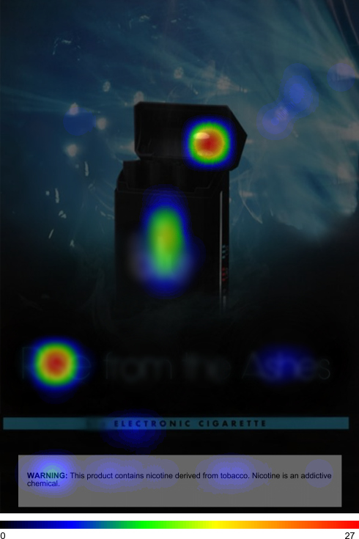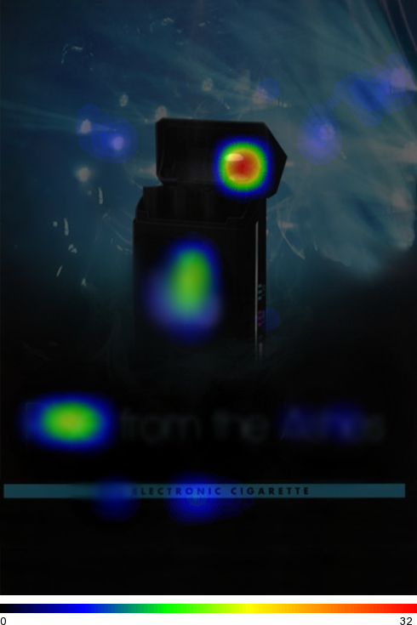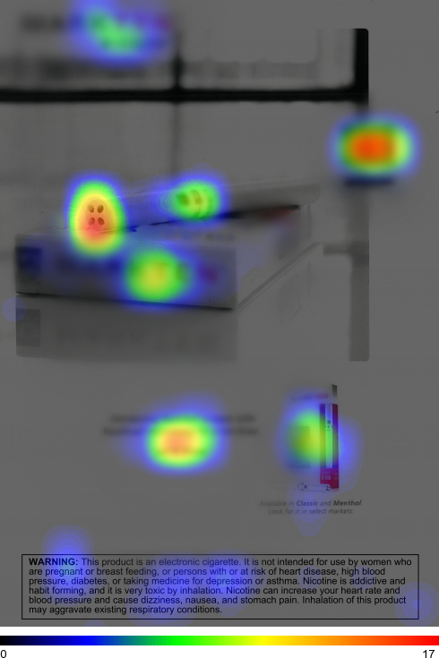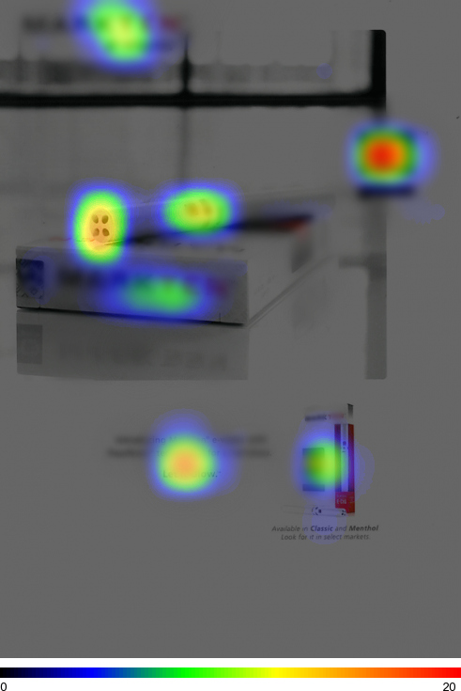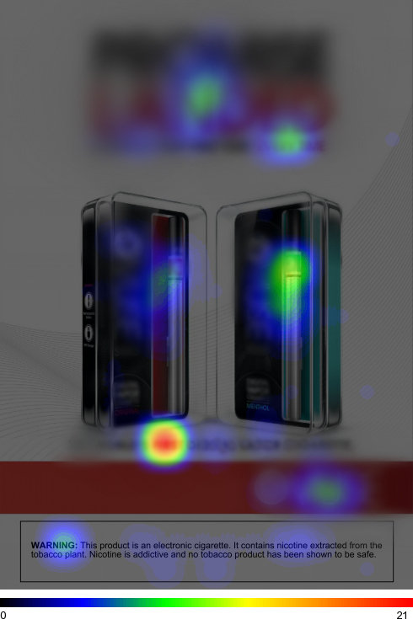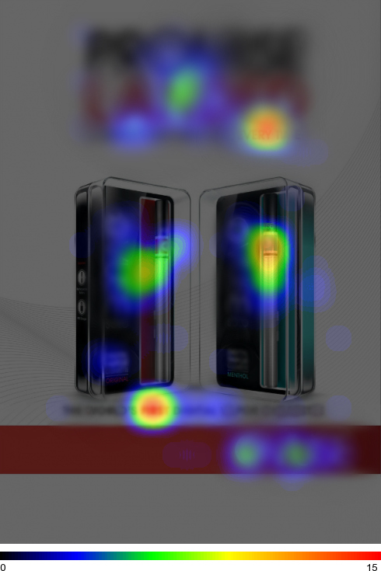
Note: For the heat map task participants in the Ad Only and Ad with Warning conditions were asked to select up to 5 areas of the ad that attracted their attention the most. Heat map colors indicate the proportion of participants reporting that a specific area of an ad attracted their attention. Coloring indicates the proportion of participants selecting an area of the ad, with higher proportions appearing in red and lower proportions appearing in blue. Ad images credit: Trinketsandtrash.org.

