Additional File 1
Note: All branding content from e-cigarette ad images is visually occluded for publication purposes.
E-Cigarette Experimental Stimuli
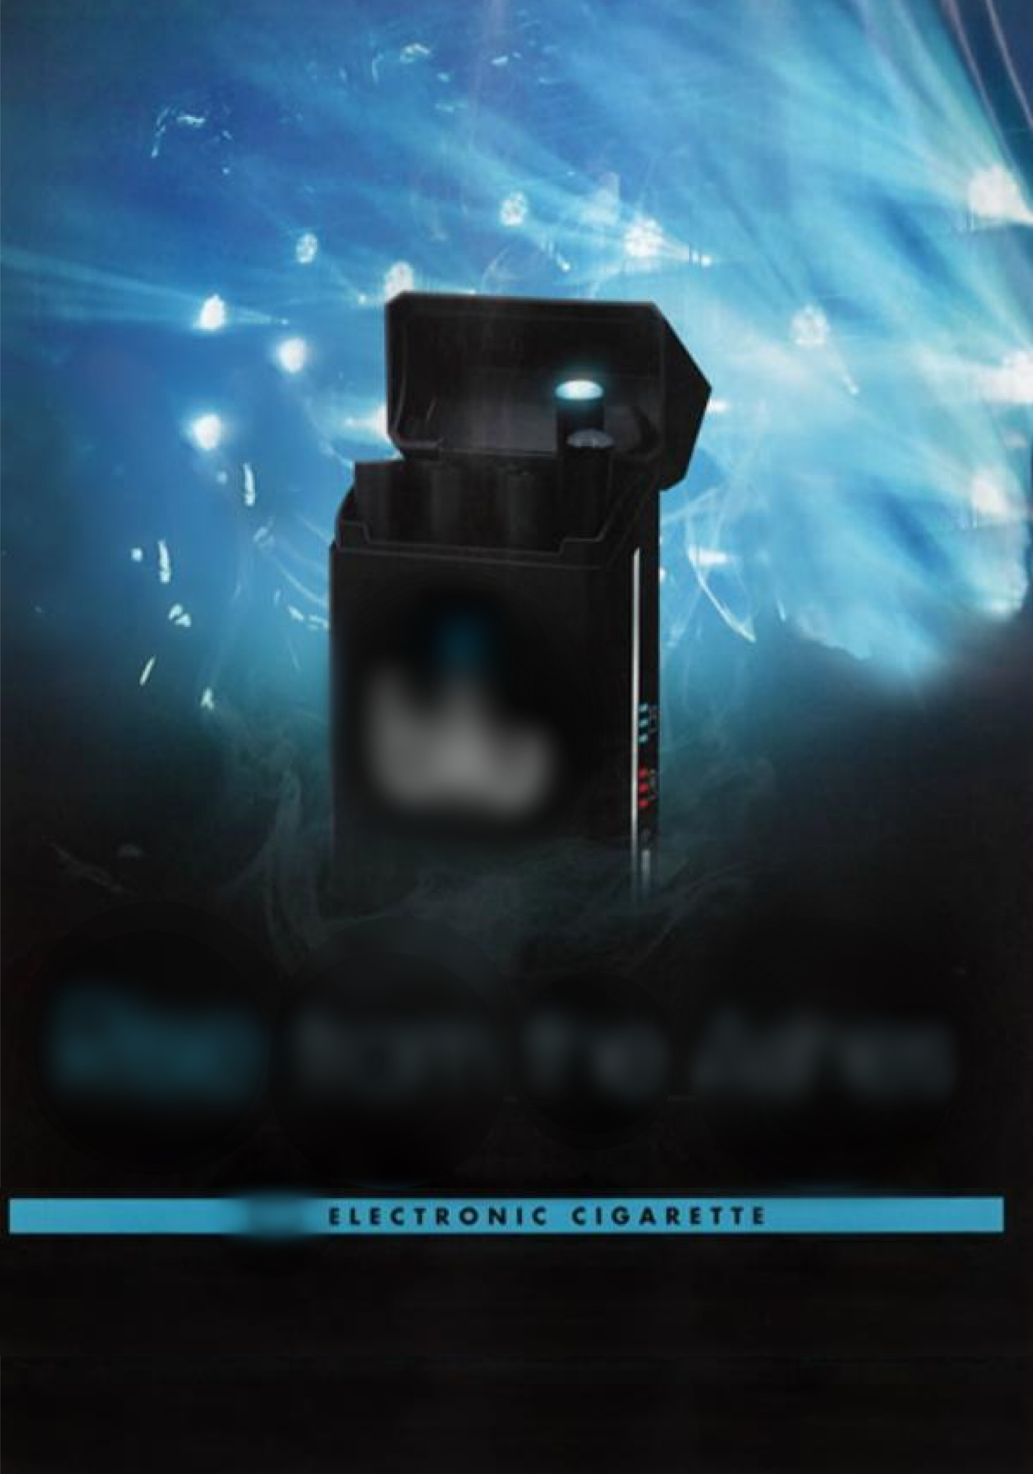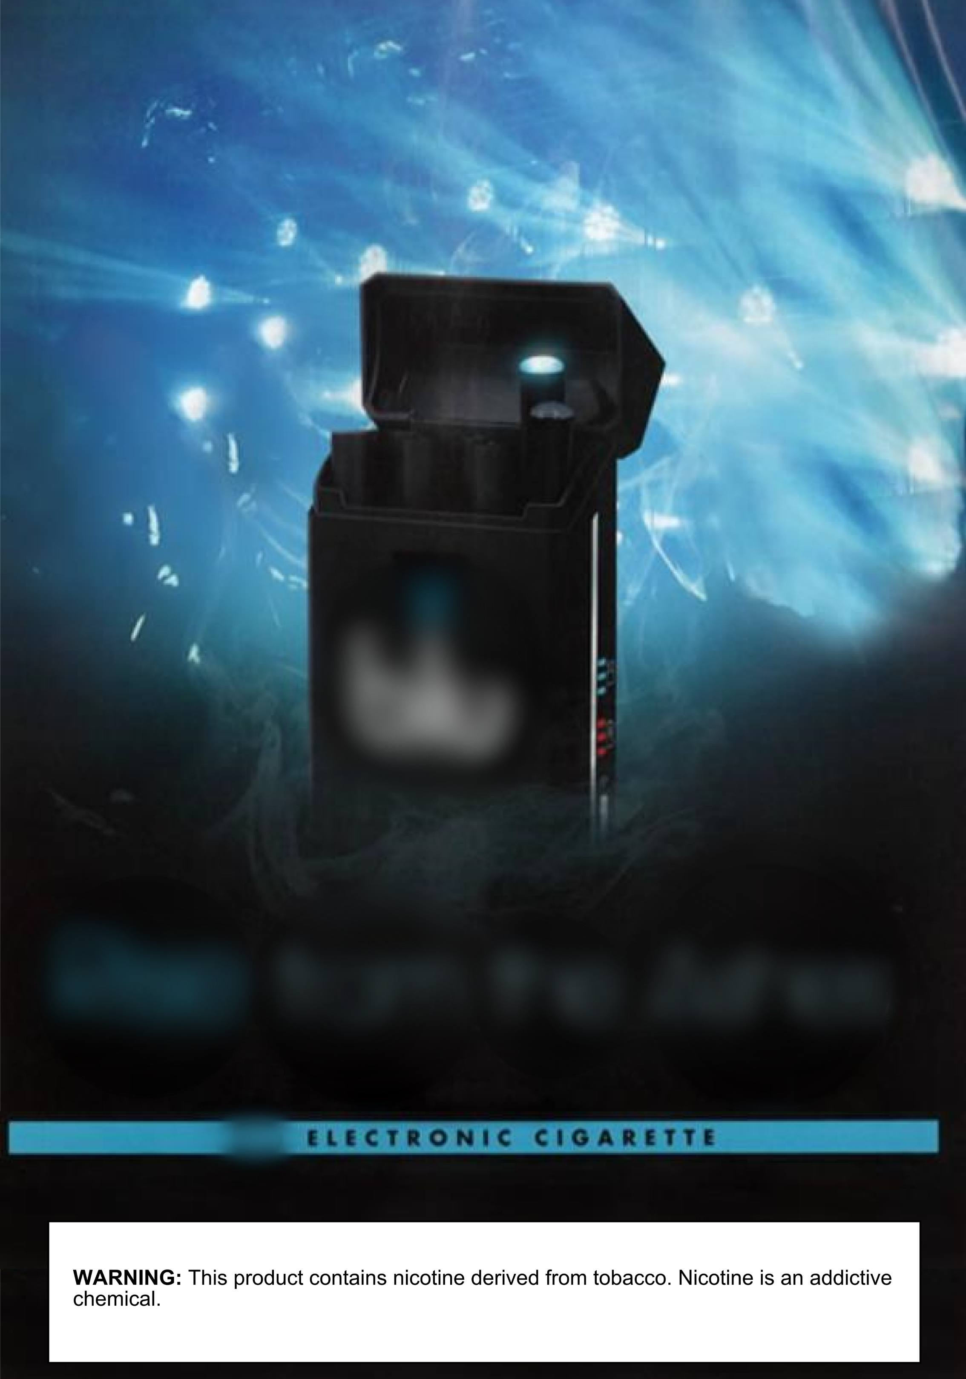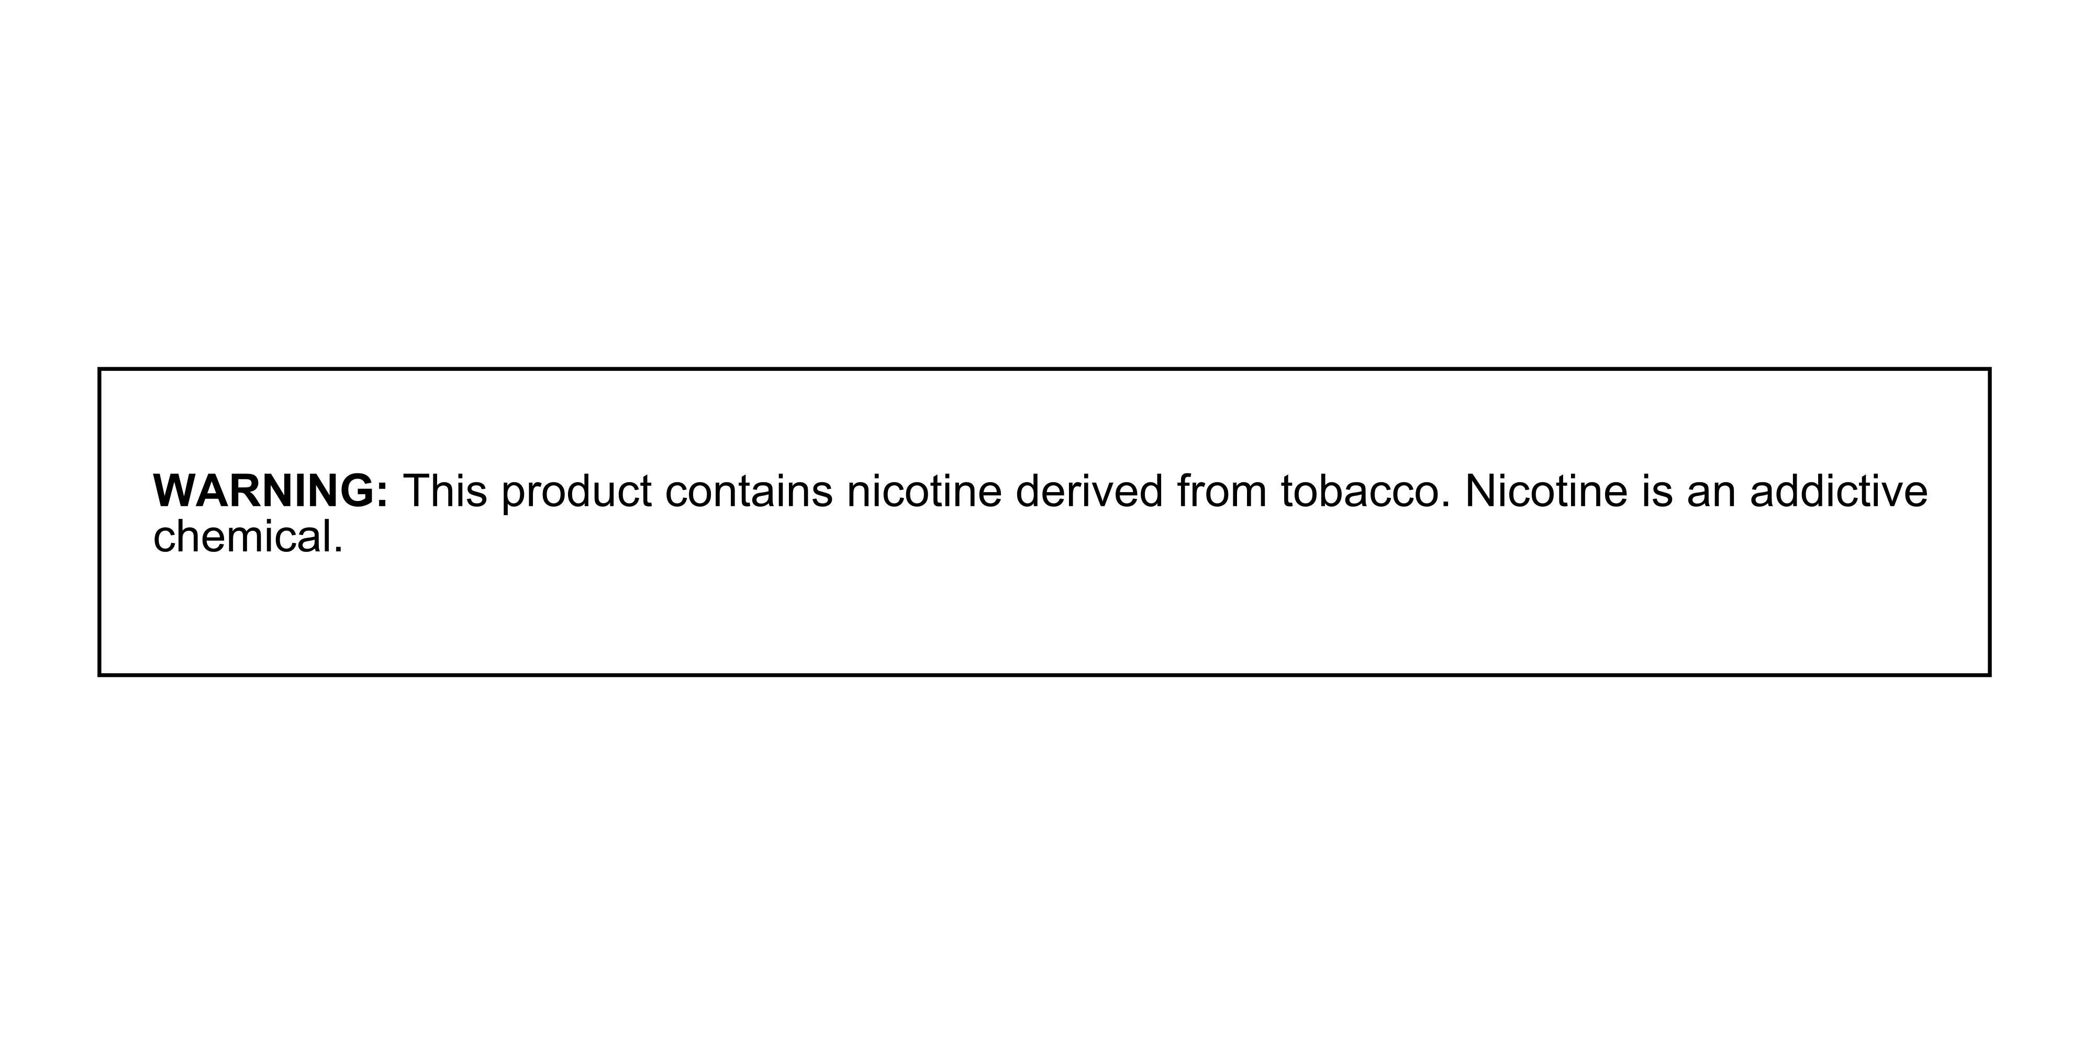
Ad Only, Blu Ad with Warning, Blu Warning Only, Blu
Ad images credit: Trinketsandtrash.org
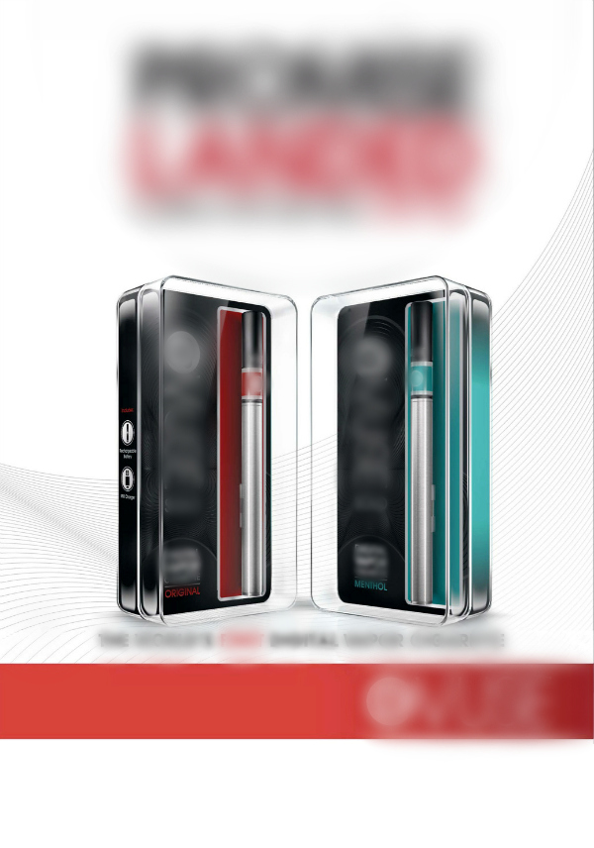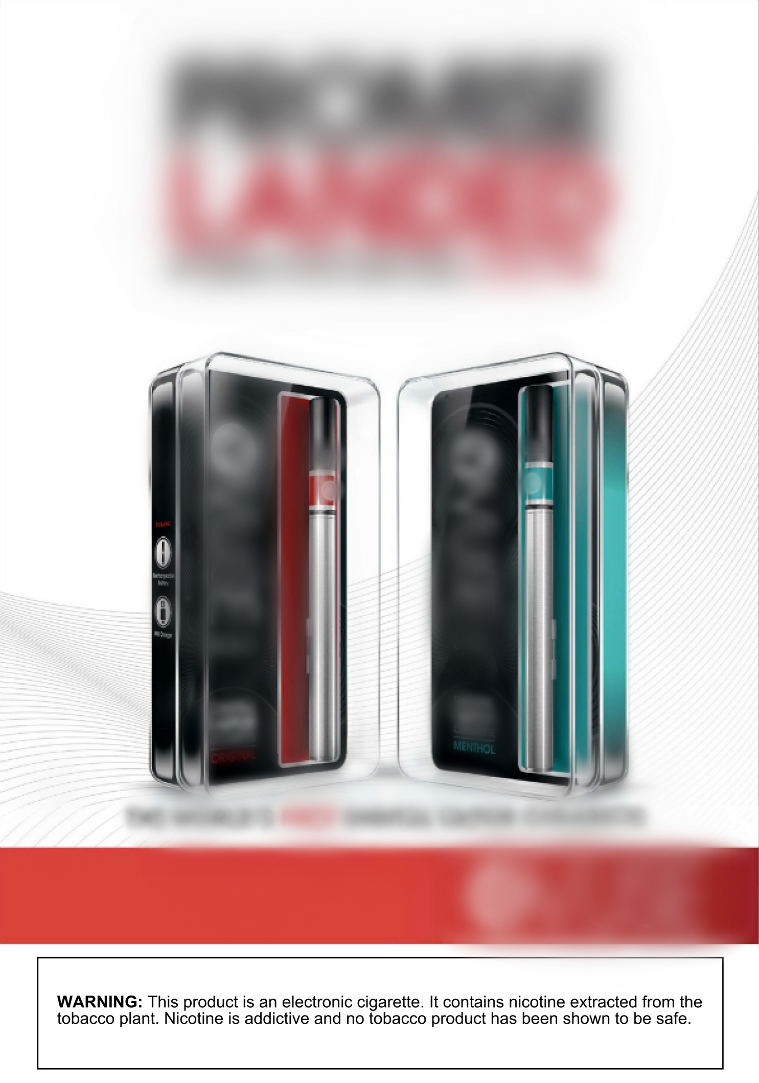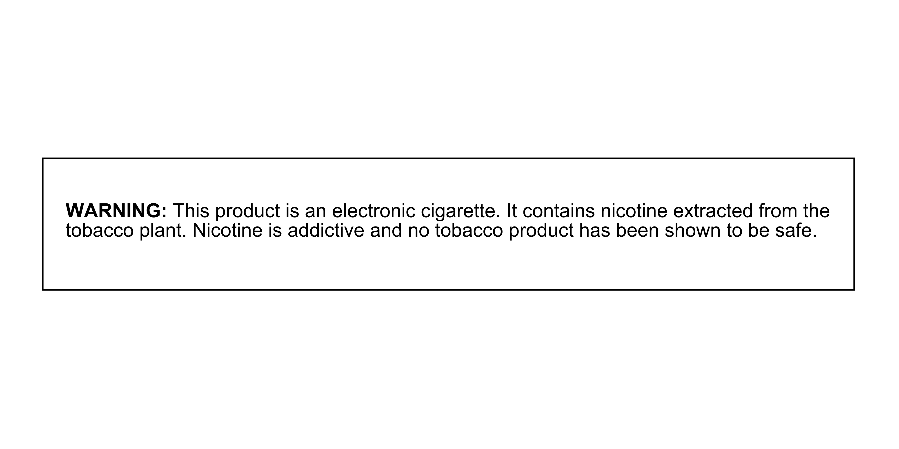
Vuse, Ad Only Vuse, Ad with Warning Vuse, Warning Only
Ad images credit: Trinketsandtrash.org

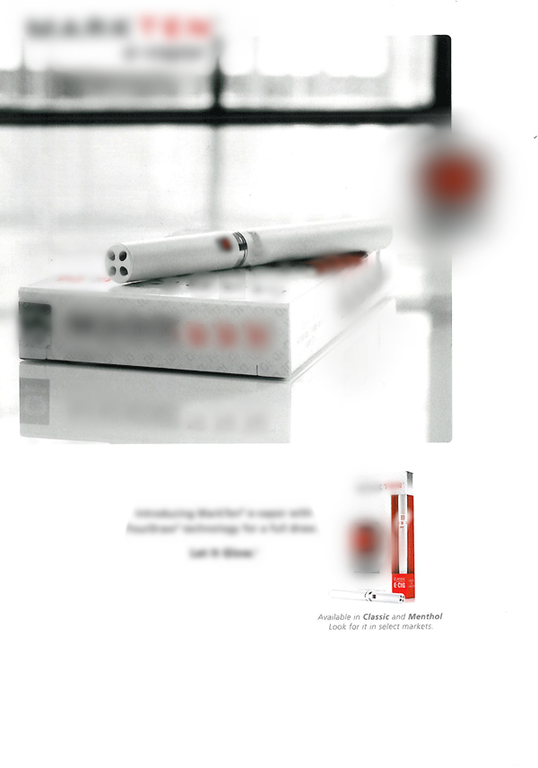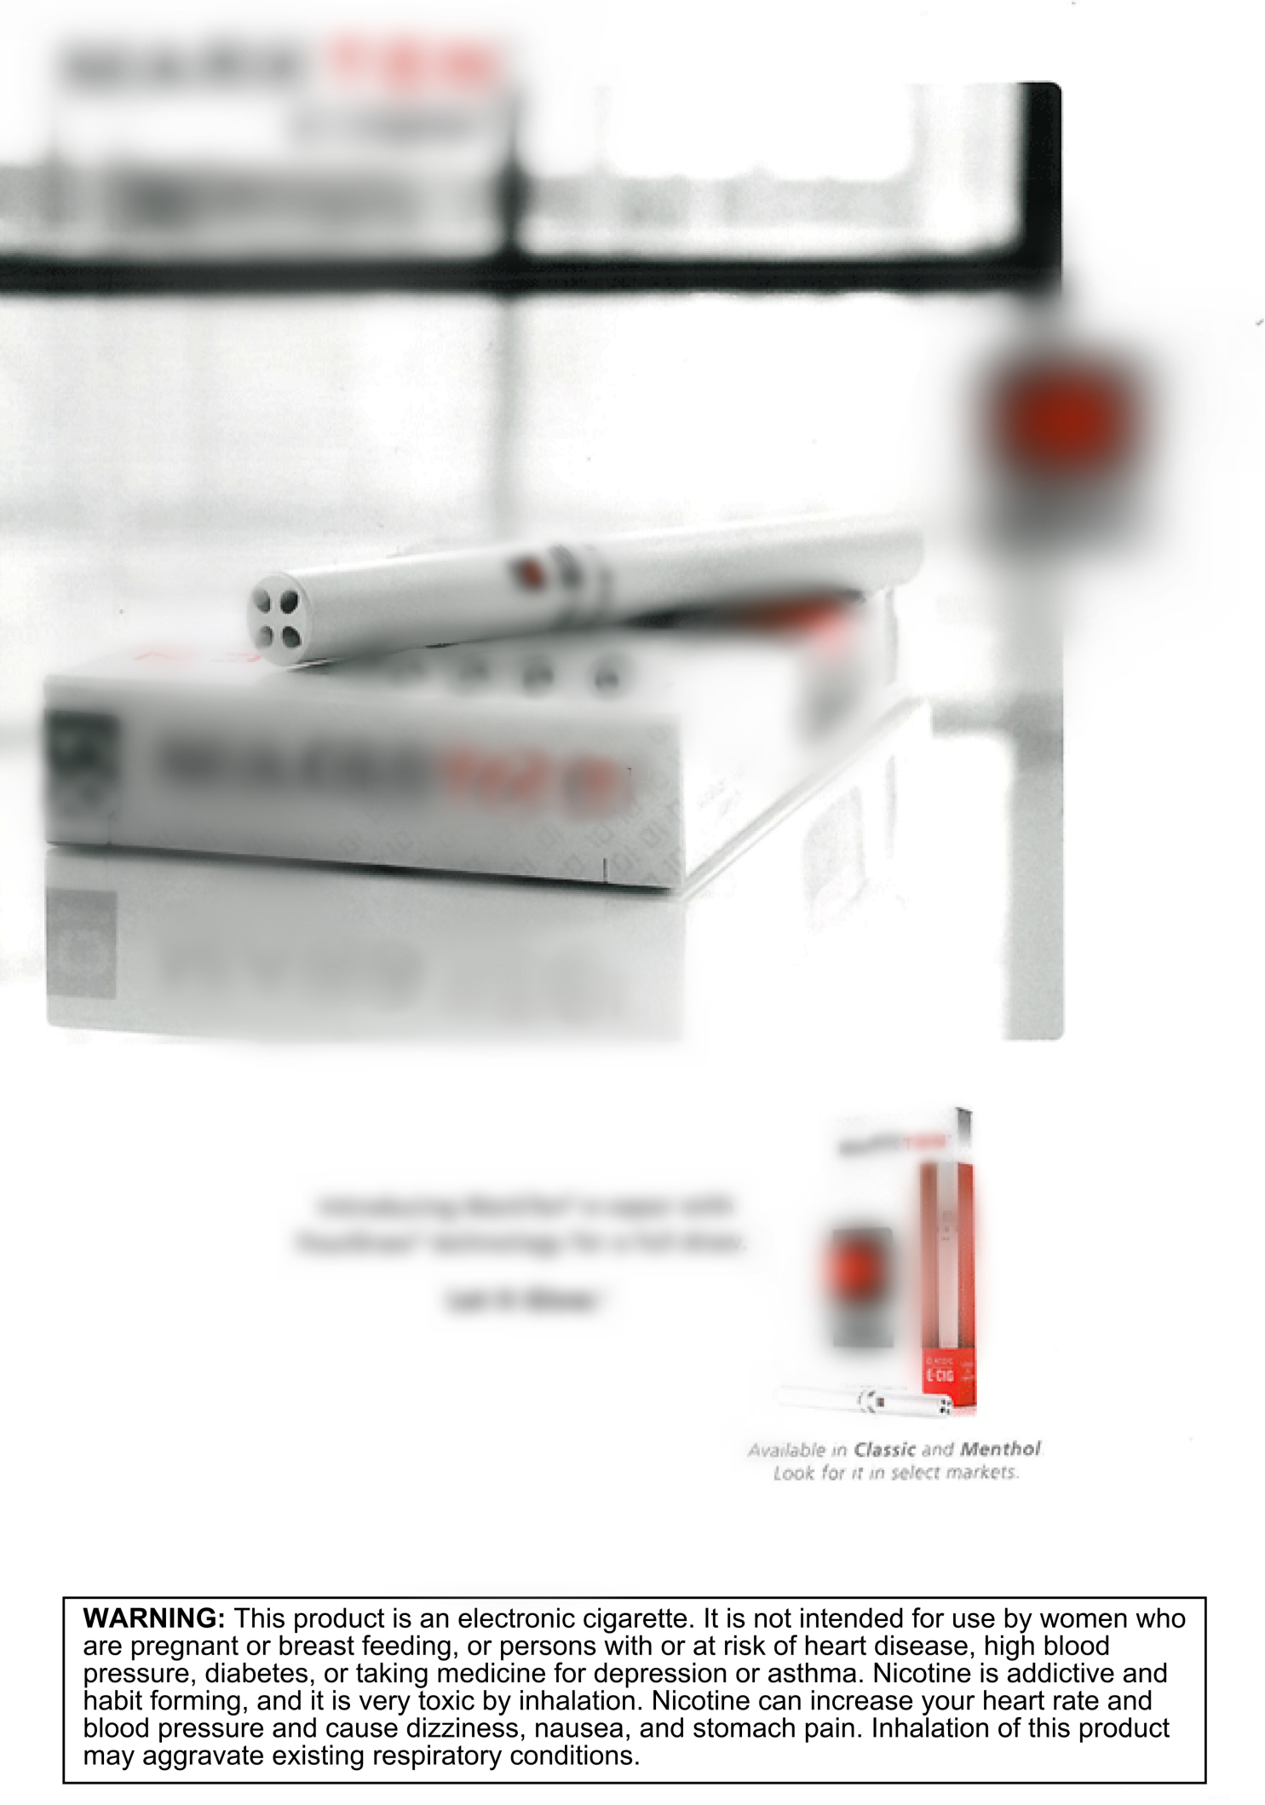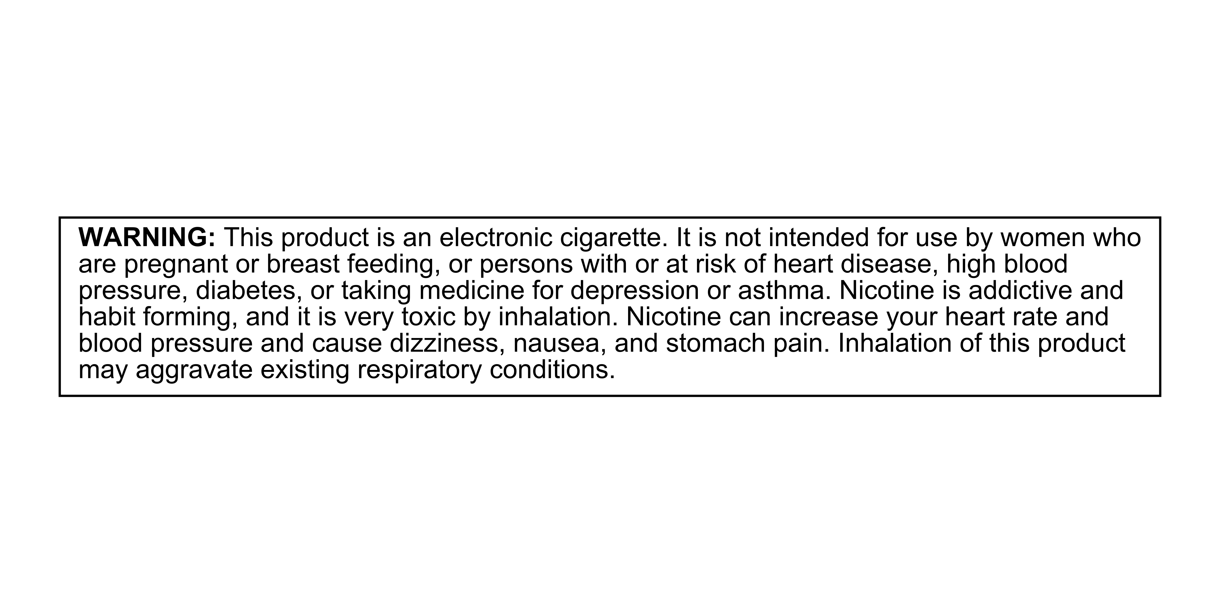

MarkTen, Ad Only Mark Ten, Ad with Warning MarkTen, Warning Only
Ad images credit: Trinketsandtrash.org

