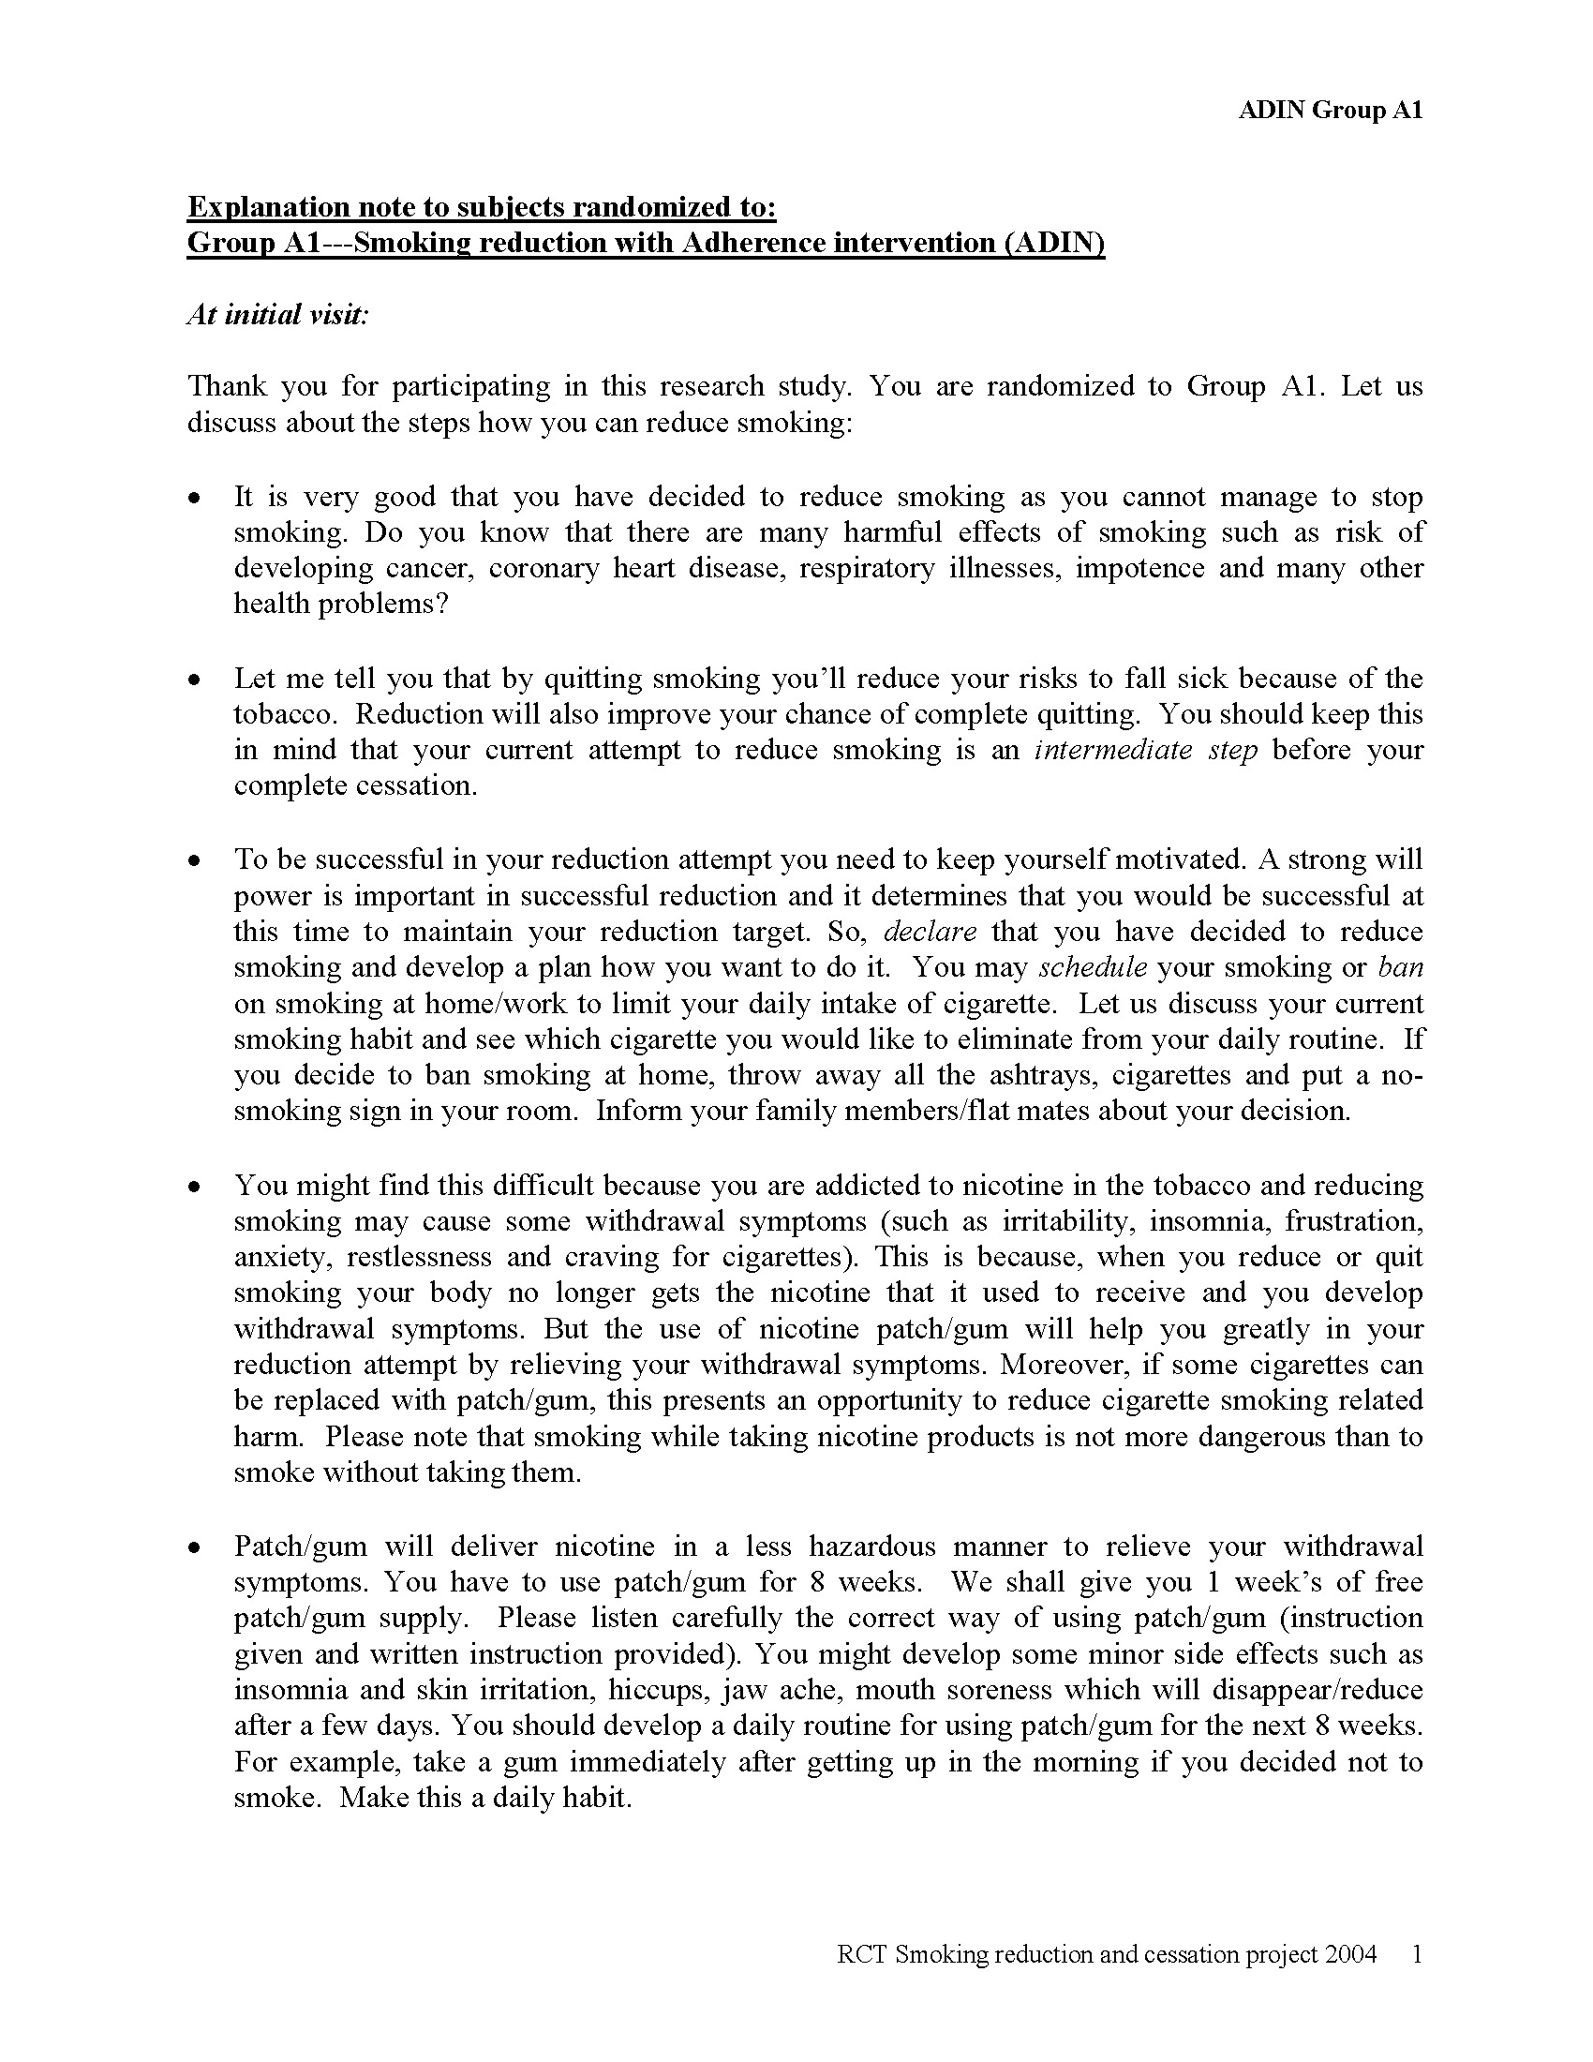
Appendix B: Manual for behavioral counseling of the intervention Group A1(Smoking Reduction + Adherence Counselling)



