Prevalence of tobacco use and determinants
Among Iraqi adolescent population. A cross
Sectional study

Dr Hamid Y Hussain * Dubai Residency training program/ DHA
Bushra Abdul Satar * Faculty of medicine, university of Baghdad

Correspondence: hussainh569@gmail.com
Key words: Iraqi Adolescents, Determinants, interventional strategies

Abstract:
Background: The use of any form of tobacco by 13–18 year old individuals is 10%. greater than other vulnerable age groups. In addition, almost one in four students (13-18 years old) who ever smoked cigarettes, smoked their first cigarette before the age of 10. Objectives: this study is aimed to study the prevalence of smoking among Iraqi adolescent population, and some determinants. Methods: A cross sectional analytical study carried out on 1750 participants selected randomly from preparatory and secondary schools in Baghdad by multistage stratified random sample through self administered structured questionnaire, Results: the study reveled that 20.8% of Iraqi adolescent population are tobacco users, cigarette smoking is the main tobacco use practice in Iraq 13.9% followed by Shisha(4.8%) and Pipe (1.4%) , the stepwise logistic regression, showed that , main predictors factors affecting smoking among this population were, Age with odds ratio (2.85), sex(2.31),Parents smoking(1.97),close friends(4.65) and illiterate education of parents (2.02 ). According to the type of tobacco use the study showed that the highest consumption rate was for Cigarettes (95 % CI = 8.94-12.22) Shisha (9 5 % CI = 9-10.8) Pipe (9 5 % CI = 6.48-8.76) Cigar (95 % CI = 2.88-4.42) Bidi (95 % CI = 0.74-2.66) Smokeless (9 % CI = 0.87-3.17) Conclusion: adolescent population are at high risk of tobacco use practice, many determinants have significant impact on tobacco use. Practice, attitude and believe are the best potential areas where an effective interventional strategies can be applied accordingly.
Introduction:
Adolescents are very critical segment of population, they make up around 1.2 billion of the world‘s 6 billion inhabitants, face a form of tobacco intimidation at an early point in their lives. (1) Surveillance of tobacco use among youth in several countries significantly showed that the problem of smoking at this particular age group is of equal concern in developed and developing countries (2). Available figures reflected a fact that the use of any form of tobacco by 13–18 year old individuals is 10%. greater than other vulnerable age groups. In addition, almost one in four students (13-18 years old) who ever smoked cigarettes smoked their first cigarette before the age of 10(3). Tobacco use is shifting from the developed world to developing countries, especially low- and middle-income Arab countries (2). One such country, which has the highest rate of tobacco consumption in the Middle East and North Africa, is Egypt and Lebanon (4). It is estimated that 34% of Egyptians are daily smokers, with males having significantly higher daily smoking rates than females (43.4% males& 4.7%), females Smoking among adolescents has also been reported to be associated with other unhealthy life styles such as alcohol consumption and illicit drug use. Adolescent smokers are also likely to be truant from school, an experience that may further jeopardize their future life chances in life (5). in the Kurdistan-Iraq Global Youth Tobacco Survey showed, prevalence of current cigarette smoking was 15.3 the study showed the impact of some factors like: parents' smoking, smoking in closest friends, male gender, having pocket money and perceptions that boys or girls who smoked were attractive( 6),the rest part of Iraq has been going under significant pressure times throughout three decades including three devastating Wars and long term sever comprehensive sanction which eventually reflect on socio- cultural context of the population led to raise new e value depleted generation. Objectives:
1. To study tobacco use determinants among adolescent population in Iraq
2. To study the prevalence of tobacco use among Iraqi adolescents
Materials and Methods:
A school-based analytical cross-sectional study conducted in both preparatory and secondary schools in, Baghdad/ Iraq. Age range (13-18) both genders, males and females, through the computer program EPI-INFO version ‗6.04‘. ,using 4 % degree of precision , estimated prevalence of tobacco use among adolescents from previous similar studies (2010),(15.3%), 1.5 design effect and 95% confidence interval , the adequate sample size selected was 1750 , using Multistage stratified random sample technique, with proportional allocation according to the number of schools. Stratification mainly based upon the regions( Two river sides regions), sex(male, female), type of schools (governmental& private) ,age categories according to the grads .The list of schools was obtained from MOE Selection of the private and governmental schools was carried out proportionally according to the number of schools; for every four private schools selected, one governmental school was selected. Sixteen private schools and four governmental schools were randomly selected from both regions (Karkh and Rusafa). For the private schools; eight schools was selected randomly from each region (four for males and four for females). As regards the governmental schools; two schools were selected randomly from each region (one for males and one for females). One class was selected randomly from each of the educational grade (preparatory 7-9) and secondary (10-12) within the selected schools and all the students in the selected classes were invited to participate in the survey. The total sample subjected for analysis is 1750.

Results:
The study reveled that prevalence of tobacco use among Iraq adolescent population is 20.8% as reflected by figure (1)(364)participants were tobacco user at the time of study, among all tobacco use about 13.9% smoke cigrates,4.8% smoke shish ,1.3% smoke Pipe, 1% smoke cigar and 0.6% smoke smokeless tobacco Cigarettes as reflected by figure( 2). Cigarette (95 % CI = 9.24-12.22) Shisha (9 5 % CI = 8-10.8) Pipe (9 5 % CI = 5.38-7.76) Cigar (95 % CI = 1.88-3.42) Bidi (95 % CI = 0.64-1.66) Smokeless (9 % CI = 0.97-2.17) Table (1) showed Frequency distribution according to age at initiation and days of smoking within last month as the highest rate was at age of ( 12-14) (35.5%) and (14 +)(35.9) age groups , X square 434.1 ,P Value =0.023, table 2 showed Frequency distribution according to smoking habits as it showed that the main source of getting tobacco use was friends (51.4),schoolmates 19.2%) and parents (10.4%) , table (3 ) Shows Distribution according to some socio-demographic characteristics as it reflects that (27.1%) of total male are smokers while only (12.7%) of total female are smokers and the highest rate of smoking were among persons of low mothers and fathers education as p values were <0.05 table (4)Distribution according to Knowledge and attitude level towards tobacco and its hazards, it showed that about (22.1%) of smokers have fair knowledge and(25.1%) good knowledge with significant Chi square test P<0.05. Table (5) shows the stepwise logistic regression, as the main predictors were Age Odds ratio (2.85), sex (2.31), Parents smoking (1.97), close friends (4.65) and illiterate education of parents (2.02)

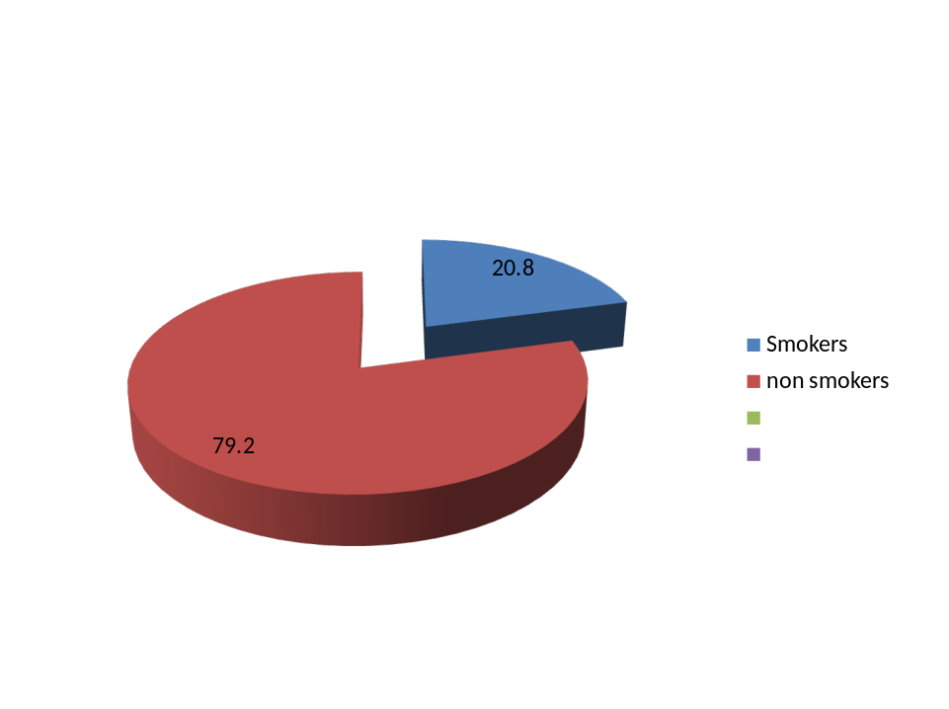

1 Figure (1) tobacco use among Iraqi adolescent population

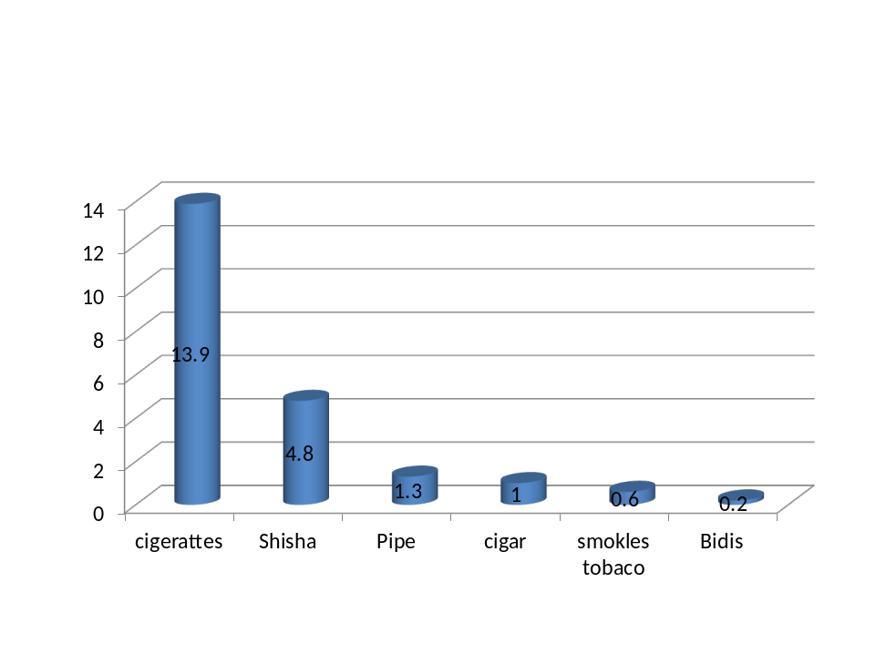
Cigarettes (95 % CI = 8.94-12.22) Shisha (9 5 % CI = 9-10.8) Pipe (9 5 % CI = 6.48-8.76)
Cigar (95 % CI = 2.88-4.42) Bidi (95 % CI = 0.74-2.66) Smokeless (9 % CI = 0.87-3.17)
Figur(2) frequency distribution of different tobacco use items among Iraqi adolesent population.

Table (1) Frequency distribution according to age at initiation and days of smoking within last month

Types of tobacco products |  |  |  |  |  |  |  |  |  |  |  |  |  |  | Variable
Chewing  tobacco  Smokeless)  ( n = 26) |  |  |  |  |  | Bide  ( n = 19) |  |  |  |  | Cigar  ( n = 44) |  |  |  | Pipe  ( n = 109) |  |  |  |  | Shisha  ( n = 156 |  |  |  |  |  | Cigarettes  ( n = 178)
% |  | No |  |  |  | % |  |  | No |  | % |  | No |  | % |  |  |  | No | % |  |  | No |  |  | % |  | Age  No
15.4  23.1  34.6  26.9 |  |  | 4  6  9  7 |  | 13.3  40.0  7.6  40.0 |  |  |  |  | 2  6  1  6 | -  52.3  25.0  22.7 |  | -  23  11  10 |  |  | 5.5  17.4  30.3  46.8 |  |  | 6  19  33  51 | 7.7  30.1  17.3  44.9 |  |  |  | 12  47  27  70 |  | 8.4  25.8  36.0  29.8 |  | <10 15  10-11 46  12-13 64  14+ 53
12.12+- 2.21 |  | 12.13+-2.03 |  |  |  |  |  | 12.14+-1.90 |  |  |  |  | 12.92 +- 2.03 |  |  |  |  | 12.88+- 2.26 |  |  |  | 12.42+- 2.07 |  |  |  |  |  | -  X +- SD
0.023 |  |  |  |  |  |  |  |  |  |  |  |  |  |  | P*
Days of tobacco use in the past 30 days

No % NO % NO % NO % NO % NO %
23.1  3.8  7.7  7.7  15.4  42.3 | 6  1  2  2  4  11 |  |  | 52.6  21.1  10.5  10.5  -  5.3 |  |  | 10  4  2  2  -  1 |  |  | 50.0  18.2  4.5  4.5  6.8  15.9 |  | 22  8  2  2  3  7 |  | 29.4  11.0  9.2  4.6  9.2  36.7 |  |  | 32  12  10  5  10  40 |  | 66.0  6.4  7.7  4.5  9.0  6.4 |  | 103  10  12  7  14  10 |  |  |  | 38.0  20.9  3.8  8.8  5.02  19.6 |  | 91  50  9  20  12  47 |  | 1 or 2  3 to 5 days  5 to 9 days  10 - 20  20 to 29  +30 days

*= ANOVA p<0.05

Table (2). Frequency distribution according to smoking habits

% | No  (n = 178) |  | Cigarette smoking habit
Source of getting first cigarette
10.4  4.6  13.8  19.2  51.8 | 25  11  33  46  124 |  | Parents-  Siblings  Relative/neighbor  Schoolmate-  Friend
Place of trying first cigarette
9.2  12.9  17.1  11.7  48.9 | 22  31  41  28  117 |  | -Home  -School  On the way to/from school  Home of a friend/relative  -Other
With whom did you first try a cigarette?
12.1  45.6  14.6  5.8  21.7 | 29  109  35  14  52 |  | -Alone  Friend/schoolmate  Relative/neighbor  Family member  Other
Duration of cigarette smoking
36.8  43.0  20.0 | 88  103  48 |  | Less than one year  1-3 years  4 years or more
Number of cigarette smoked / day
66.5  23.8  4.6  5.0 | 159  57  11  12 |  | <5  5-10  11-15  >15
-  4.43+-4.29 |  | X +- SD
During the past 30 days (one month), how did you usually get your own cigarettes?
48.1  13.8  20.5  1.52  16.31 | 115  33  49  3  39 |  | -I bought them in a store, shop, supermarket,.  -I gave someone else money to buy them for me  -I borrowed them from someone else  -An older person gave them to me  -I got them some other way
During the past 30 days (one month), did anyone ever refuse to sell you cigarettes because of your age?
79.4  20.5 | 190  49 |  | No  Yes

Table (3) Distribution according to the use of different types of tobacco and some socio-
p | Total |  |  | use | Tobacco | Socio demographic characteristics
p | Total | % | no  No | % | yes  no | Socio demographic characteristics
0.000* | 512 | 66.0 | 388 | 34.0 | 124 | School type/ Governmental
0.000* | 1238 | 35.1 | 998 | 65.9 | 240 | private
 |  |  |  |  |  | Age(Years)
 | 462 | 8.0 | 397 | 17.8 | 65 | <14
 | 593 | 58.0 | 438 | 42. | 155 | 14-16
0.000* | 645 | 40.5 | 501 | 39.5 | 144 | 16+
 |  |  |  |  |  | Sex
0.000* | 981 | 72.9 | 805 | 27.1 | 266 | male
 | 768 | 87.3 | 670 | 12.7 | 98 | female
 |  |  |  |  |  | Grade of Education
0.000* | 798 | 78.0 | 622 | 22.0 | 176 | 7-9
 | 952 | 81.3 | 764 | 19.7 | 188 | 10=12
 |  |  |  |  |  | Mother education
 | 190 | 45.3 | 86 | 54.7 | 104 | illiterate
 | 206 | 53.6 | 110 | 46.6 | 96 | primary
0.000* | 241 | 73.5 | 177 | 26.5 | 64 | preparatory
0.003* | 526 | 90.2 | 474 | 9.8 | 52 | secondary
 | 587 | 82.3 | 539 | 17.7 | 48 | University/higher
 |  |  |  |  |  | Father education
 | 200 | 51.4 | 102 | 49.0 | 98 | illiterate
 | 250 | 62.7 | 157 | 37.2 | 93 | primary
0.000* | 270 | 70.4 | 190 | 29.6 | 80 | secondary
0.000* | 381 | 79.9 | 308 | 19.1 | 73 | preparatory
0.000* | 649 | 90.8 | 589 | 9.2 | 60 | University/higher

Table (4) Distribution according to Knowledge and attitude level towards tobacco and its hazards,

 | Total |  | Tobacco use |  | N0n tobacco use | variable
 |  | % | N0 | % | no | knowledge
0.019 | 478 | 16.95 | 81 | 83.05 | 397 | Poor
 | 639 | 22.1 | 141 | 77.9 | 498 | Fair
 | 633 | 22.5 | 142 | 77.5 | 491 | Good
 |  |  |  |  |  | Attitude
 | 658 | 25.1 | 165 | 74.9 | 493 | -Ve
0.000* | 1092 | 18.3 | 199 | 81.7 | 893 | +ve
Chi-Square test *p<0, 05
OR = Odds Ratio CI = Confidence Interval Model, p =0.000

Table (5) stepwise logistic regression of factors affecting any tobacco use among the
Study sample

95% CI  Lower | Upper | OR | P | B | Independent variable
2.93 | 1.48 | 2.08 | 0.000 | .0733 | Type of school/private
4.41 | 1.78 | 2.881 | 0.000 | 1.032 | Age -16-14
3.42 | 1.57 | 2.31 | 0.000 | 039 | SEX
2.77 | 1.040 | 1.97 | 0.000 | 0.677 | PARENTS SMOKING
2.87 | 1.21 | 1.86 | 0.005 | 0.621 | SIBLINGS SMOKING
 |  |  | 0.000 |  | CLOSE FRIEND SMOKING
3.89 | 1.83 | 2.67 | 0.000 | 0.981 | SOME
14.39 | 4.65 | 8.18 | 0.000 | 2.102 | MOST/ ALL
 |  |  | 0.001 |  | EXPOSURE TO SMOKING IN PUBLIC PLACES
2.24 | 1.04 | 1.52 | 0.330 | 0.419 | OCCASIONALLY
4.68 | 1.62 | 2.75 | 0ز000 | 0.013 | REGULARLLY
 |  |  | 0ز000 |  | ATTITUDE/ positive
4.12 | 1.37 | 2.37 | 0.002 | 0.865 | Neutral
 |  |  | 0.000 | 1.469 | Negative
 |  |  | 0.001 |  | Father Education/University
1.80 | 0.48 | 0.72 | 0.114 | 0.372 | secondary
2.75 | 1.5 | 1.78 | 0.009 | 0.578 | Primary/preparatory
4.79 | 1.15 | 2.02 | 0,047 | 0.788 | Illiterate/write
 |  | 0.11 | 0.000 | 2.232 | constant

Discussions:

By current study, the prevalence rate of smoking among Iraq adolescent (20.8%) (349) is almost in similar with the prevalence of tobacco in Philippines (2003),(7) but it was higher than previous studies from India (2005) (8) where On the other hand, it was lower than a previous surveys from Yemen (2003) (8) and Saudi Arabia (2007) where the prevalence of any current tobacco use was 19.3 % & 17.3% respectively. About (32.5 %) was reported by Global Youth Tobacco Survey (GYTS) in South Africa (2001). (9).According to data presented from 75 sites in 43 countries and the Gaza Strip/West Bank region by the Global Youth Tobacco survey (2002) (10) showed current use of any tobacco product ranging from 3.3% to 62.8% with current cigarette smoking ranging from less than 1% to39.6%. Cigarettes smoking were the predominant form of tobacco use among the current tobacco users (10.7%). A similar finding was reported by The GYTS conducted in Greece (2005), (11) but it was higher than that reported by studies in Oman (2006) (12) and UAE (2010) (13) where the prevalence of current smoking cigarettes was 4.5% and 9.8% respectively. Results from Jordan (2002) (14) &Tehran (2003) (15) reported that the prevalence of cigarette smoking was 28.6% & 28.2% respectively, which were higher than the present study
As for the multiple logistic regression analysis, Pakistan study (2003) (16) showed that, the significant factors related to adolescent smoking were school type (governmental schools), parental and uncle smoking were associated with double risk of smoking in addition to peer smoking (adjusted OR=6.2). Boys who spent most of their leisure time outside home were more likely to smoke (adjusted OR = 3.9).Similarly Pokhara study (2003), (17) reported that, boys were 3.15 times more likely to use tobacco compared to girls, adolescent students from non-governmental schools were 2.58 times more likely to use tobacco than adolescent students from governmental schools. Adolescent students were 1.79 times more likely to use tobacco if at least one family member (parents, siblings and other members residing permanently) used tobacco than those who had no family members using tobacco. Adolescent students who had at least one best friend who used tobacco were 5.93 times more likely to use tobacco than those who had no best friends using tobacco. Students who were regularly exposed to second hand tobacco smoke in public places were also 2.69 times more likely to become tobacco users than those who were never exposed.
Conclusions:
Smoking rate were among Iraqi adolescents found to be among the high rates prevalence in the middle east countries ,starting smoking where found to be as early as 10 years old with the average age of around twelve for the different types of tobacco use products. Cigarette smoking was the most prevalent type followed by shisha and pipe. And smoking significantly impacted by many determinants
. ٌ Recommendations
Smoking prevention educational programs should be provided especially in elementary school and intensified in middle/ junior high school. School policy development and enforcement on tobacco use and Announcing schools places as tobacco-free places, to raise the level of awareness of the hazards of tobacco use and second hand exposure, to change student‘s behavior and prevent tobacco initiation. Developing and enforcing a school policy on tobacco use. Announcing schools and other public places as ―tobacco-free places. Parental counseling and training. Supporting school-based programs to prevent tobacco use. Development of skills to resist peer pressure and to refuse tobacco use among primary grades students Mobilization of tobacco nonusers in motivating adolescent students to prevent initiation and cessation of tobacco use would help to
Create a supportive environment. And initiating peer education program.

Declaration

- Ethical concerns have been met
- No conflict of interest
- No fund received from everywhere.
References:
1- Jha P, Chaloupka, FJ.Tobacco Control in Developing Countries. Oxford United Press for the World Bank and WHO, Oxford 2000.

2- Corrao MA, Guindon GE, Sharma N, Shokoohi DF. Tobacco Country Profiles. American Cancer Society. Atlanta: GA 2000.

3. Steptoe A, Wardle J, Cui W. An international comparison of tobacco smoking, beliefs and risk awareness in university students from 23 countries. Addiction 2002; 97:1561-1571.

4. Corrao MA, Guindon GE, Sharma N, Shokoohi DF. Tobacco Country Profiles. American Cancer Society. Atlanta: GA 2000.

5. The Global Youth Tobacco Survey Collaborative Group (US Centres for Disease Control and Prevention; the World Health Organization, the Canadian Public Health Association, and the U.S. National Cancer Institute). Tobacco use among youth: a cross country comparison. Tobacco Control 2002, 11: 252-270.

6. Seter Siziya1, Adamson S Muula*2 and Emmanuel Rudatsikira, Conflict and Health 2007, 1:13 doi: 10.1186/1752-1505-1-13)

7. - The Global Youth Tobacco Survey Collaborative Group Differences in worldwide tobacco use by gender: Findings from the Global Youth Tobacco Survey. Journal of School Health 2003; 73(6): 207-215.

8. - Tosh AK, Simmons PS. Sexual activity and other risk-taking behaviors among Asian-American adolescents. J Pediatr Adolescents Gynecol 2007; 20: 29-34.

9. Fikri M, Al-Matroushi M .Global youth tobacco survey .UAE report. Central health education department, Ministry of health.2010.

10.. - Al-Bedah A M, Qureshi N A ,Al-Guhaimani H I , Basahi J A .The Global Youth Tobacco Survey-2007.Comparasion with the Global Youth Tobacco Survey 2001-2002 in Saudi Arabia. Saudi Med J 2010; 31 (9):1036-1043.

11. - Swart D, Reddy P, Pitt B , Panday S.The prevalence & determinants of tobacco-use among Grade 8 – 10 learners in South Africa. MRC, Cape Town, 2001.

12. - Kyrlesi A, Soteriades ES, Warren CW. Tobacco use among students aged 13-15 years in Greece: the GYTS Project. BMC Public Health 2007; 7:3.

13. Jaffer YA, Afifi M, Al Ajmi F. Knowledge, attitudes and practices of secondary-school pupils in Oman. Health compromising behaviors. Eastern Mediterranean health journal 2006; 12(1/2):35–49.
14. - Haddad LG, Malak MZ. Smoking habits and attitudes towards smoking among university students in Jordan. Int J Nurs Stud 2002; 39, 793-802.

15- Heydari G R , Milani H S, Hosseini M, Masjedi M R. Attitude of High School Students of Tehran towards Tobacco Use. Tanaffos 2004; 3(11), 29-35.

16. Paudel D. Tobacco use among adolescent students in secondary schools of Pokhara. Summary reports. Master‘s Degree in Public Health (MPH 5th Batch) Maharajgunj Campus, Institute of Medicine Tribhuvan University, Nepal .April, 2003.

17. - Rozi S, Akhtar S, Ali S, Khan J. prevalence and factors associated with current smoking among high school adolescents in Karachi, Pakistan 2005; 36(2):498-504.

